
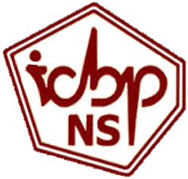


JOINT INTERNATIONAL CONFERENCE
under the aegis of the ROMANIAN ACADEMY
42nd ANNIVERSARY SYMPOSIUM OF THE
INSTITUTE OF CELLULAR BIOLOGY AND PATHOLOGY “NICOLAE SIMIONESCU”
and
38th ANNUAL SCIENTIFIC SESSION OF THE ROMANIAN SOCIETY FOR CELL BIOLOGY
From basic cell biology to personalized medicine during COVID-19 pandemic;
creativity and vision in a rapidly changing world

Poster Guidelines

Due to the virtual nature of the conference, we only accept Electronic Posters (E-Posters) in PDF format.
Printed posters or photographs of printed posters will NOT be accepted.

Poster Submission Deadline:
October 25, 2021

Title of the Poster:
It is recommended to keep the title of the poster identical to the submitted abstract. Slight variations which do not change the concept of the abstract are permitted.

Poster size and format:
Poster must be submitted in PDF format. It is recommended to make your poster in PowerPoint (Portrait mode, A0 standard size - 841 x 1189mm) and then save it as a one-page PDF before sending it to rscb2021@icbp.ro. The top of the Poster should display the following information: Title of your Paper, Name(s) of the Author(s) and Affiliation(s).
Make sure that the specific sections (such as the background, methods, results, and conclusions) are easily locatable in the poster.
Use only static images and do not embed any videos or animation in your poster.

PLEASE VERIFY THAT YOUR FINAL PDF FILE DOES NOT EXCEED 5MB OF INFORMATION BEFORE SUBMITTING!

NOTE: All the posters will be uploaded on the event webpage and accessed via password.

